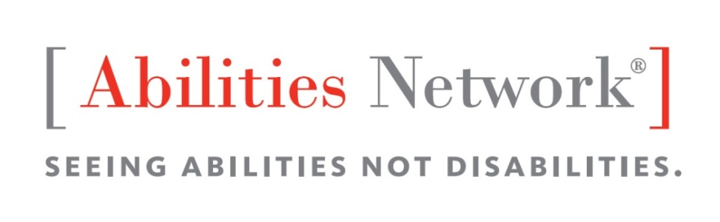

We will be holding our
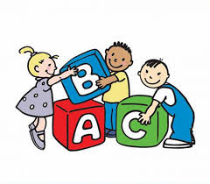
Family Child Care Academy

With this completely free academy you will receive:
- 12 hours of free COK training and MD Excels assistance
- Networking opportunities
- Language and Literacy screenings for children in your care
- Social and emotional screenings for children in your care
- Resources for language and literacy development
- In home support for you and the children in your care to prepare them for kindergarten.
Trainings will be held on Feb. 15 (snow date 2/22); March 15 (snow date 3/22); April 19; May 17; and June 7.
Training Institute 1, Abilities Network Headquarters
8503 La Salle Road, Towson, Maryland 21286

Initial training and networking dinner Wednesday, Feb.15, 2017
from 6:30-9:30 pm
Enrollment is limited so call now to be a part of this exciting opportunity!

For questions or to register, please contact
Stephanie at 443-608-9350
or email at scooper@abilitiesnetwork.org
or
Jenn at 443-761-5092
or email at jjurch@abilitiesnetwork.org
This program is made possible through support of the Baltimore Community Foundation
www.abilitiesnetwork.org
Providing quality services since 1964

